No.：

**Membership Agreement**

Intelligent Terminal Microelectronics Association Limited, a Hongkong-based company with its principal place of business at Flat 3917, 39/F., Kin Wa House, Kin Ming Estate, Tseung Kwan O, N. T., HONG KONG (Hereinafter “**Association**” or “**ITMA**”);

and

YOUR COMPANY NAME, a corporation, having its registered office at…… (Hereinafter “**Intrant**” or “**Member**”)

**RECITALS**

WHEREAS, the Association is a non-profit industrial standards organization voluntarily composed of enterprises and institutions in the terminal and microelectronics industries. Its main scope of work is to define microelectronics technology standards for smart terminals and to standardize the market promotion of related products.

WHEREAS, **Intrant** voluntarily applied to join the Association by submitting Application for Membership to the Association, and the Association agreed to accept **Intrant** to be a **Senior** Member.

NOW, THEREFORE, the Association and **Intrant**, in accordance with the principle of voluntariness and fairness, agree as follows:

1. **DEFINITIONS**

All headings used in this Agreement are inserted for convenience and are not intended to affect or alter the meaning or interpretation of this Agreement. For purposes of construction and interpretation of this Agreement, the word “including” (and variations thereof such as “includes” and “include”) and the phrase “such as” will not be deemed to be terms of limitation, but rather will be deemed to be followed by the words “without limitation.” Any reference to “herein” or “hereunder” in this Agreement, unless stated otherwise, refers to this Agreement. References to “Sections” in this Agreement include all subsections thereof (e.g., Section 5 includes Sections 5.1, 5.2, 5.3, and 5.4). For purposes of this Agreement, capitalized terms (whether in singular or in plural form) that are not otherwise defined are defined as follows:

* 1. “**Affiliate(s)**” means, as to one Party, any other Person that directly or indirectly controls, is controlled by, or is under common control with the Party, respectively, where “control” of a Person means ownership of more than fifty percent (50%) of (i) the voting power of the outstanding voting stock or other voting securities or equity interests of such Person or (ii) other interests the holders of which are entitled to vote for the election of the board of directors or other applicable governing body of such Person, and only as long as such control exists.
  2. **“Articles”**means the articles of association of the Association.
  3. “**Effective Date**” refers to the date on which the last party signs or seals the Agreement when the authorized representatives of both parties sign the Agreement.
  4. “**Parties**” means Association and Intrant, collectively.
  5. “**Party**” means Association or Intrant individually.
  6. “**Membership class**”: The membership class defined by the Association includes Board member, Executive member, Senior member, General member and Adopter member. The member rights of different Membership classes are listed in Annex I.

1. **Rights and Obligations**
   1. Intrant agrees to strictly abide by Articles of the Association, fulfill management procedures and membership obligations such as membership fee payment demand, etc., and enjoy the membership rights corresponding to its Membership class.
   2. Intrant may, in response to the Association's request, offer opinions and suggestions to the Association based on the rights corresponding to its membership class when the Association intends to amend or issue new policies or regulations. Once the amended or newly issued policies or regulations take effect, Intrant shall unconditionally comply with and fulfill the amended or newly issued policies or regulations.
   3. Intrant shall submit a Membership Class Change Application to the Association when Intrant intends to upgrade its membership class from an Adopter member to a higher class of membership, such as a General member, Senior member, or Executive member. Upon the Association’s approval, both Parties shall sign a new membership agreement corresponding to the new Membership class. Intrant must pay the membership fee if upgrading from an Adopter member to a higher membership class, or make up the membership fee difference between the membership classs before and after the change for that year.
   4. As a member of the Association, Intrant shall be obliged to:
2. Adhere to the Articles of the Association, the Association’s Intellectual Property Policy, and the consensus reached by the committees and Workgroups; implementing the resolutions of the general meeting and the directors;
3. Upholding the legal rights and interests of the Association, including its intermediate and final research outcomes, and refrain from the dissemination of non-public documents of the Association to non-members, whether individuals or entities;
4. Actively participating in the Association's standard setting, marketing promotion and other relevant initiatives;
5. To publicize, implement and enforce standards developed by the Association;
6. Paying membership fee with the exception of the Adopter Member;
7. Actively reporting to the Association Secretariat any violations of the rights and interests of the Association.
   1. As a member of the Association, Intrant’s Affiliates have the right to participate in any activities of the Association.
8. **Fee(s) and Payment**
   1. Annual Fee. The Association is entitled to levy a membership fee to its members and members shall pay the membership fee annually to the Association upon its being accepted as such. The annual membership fee standards for Board members, Executive members, Senior members and General members are listed in Annex II. Adopter member do not need to pay any membership fees.
   2. Bank Details. Membership fees shall be paid (or remitted) to the Bank Account designated by the Association, as listed in Annex III.
   3. Taxes and Costs. Intrant shall pay the membership fee in full within one month from the Effective Date of this Membership Agreement, and bear the taxes and costs required by law as well as the remittance procedures. In case of special circumstances, Intrant may apply for payment delay, but the payment delay shall not exceed four months from the Effective Date of the Agreement, or the invoice date.
   4. Membership class change. During the term of the Agreement, if Intrant's Membership class is downgraded, such as from Board member to other Membership class, or from Executive member to General member, the Association would not refund the membership fee difference between the different membership classes in the year of class downgrading.
   5. Fee adjustment. The Association may adjust the membership fee according to actual operation situation as well as based on the membership fee management procedures of the Association, and shall issue the fee adjustment on the official website of the Association (https://www.itma.org/cn/about/membership). If the membership fee is adjusted during the term of the Agreement, Intrant shall pay the membership fee in accordance with the requirements and standards specified in the Agreement.
9. **Confidentiality**
   1. Confidential Information disclosed in writing. The disclosing party shall mark the name of the disclosing party, the date of disclosure and "confidential" or similar words on it.
   2. Confidential Information disclosed orally or otherwise in a non-written manner. The disclosing party shall compile the disclosed confidential information, the name of the disclosing party and the date of disclosure in written form and deliver it to the receiving party within 30 days from the first disclosure date.
   3. The Association shall not be liable for any losses or damages suffered by Intrant due to the use of the Confidential Information disclosed by Intrant to the Association by other members of the Association in violation of their confidentiality obligations. Without Intrant's consent, the Association shall not disclose Intrant's confidential information to any third party. The confidential information disclosed by the Association to Intrant shall not be disclosed by Intrant to any third party until the Association makes it public or consents to its disclosure.
   4. Within five years after Intrant withdraws from the Association, both parties shall still be obliged to keep the confidential information confidential and shall not disclose it to any third party that has no confidentiality obligation with the Association.
10. **Representations and Warranties**
    1. Intrant guarantees that it has an independent legal person status and is engaged in technology research and development, testing services, production and sales, standard formulation, market promotion, platform, manufacturing, academic research, media services and other works in the smart terminal and microelectronics industry chain.
    2. Intrant warrants that any materials it provided to the Association are accurate, true and do not infringe legitimate rights and interests of any third party. If providing false or untrue materials or information, Intrant shall be liable to failure to enjoy the membership rights or other disputes caused thereby.
    3. The Association guarantees that Intrant can enjoy the rights corresponding to its membership class fairly and without discrimination.
11. **Notification**
    1. In the event of significant organisational change, mergers or acquisitions, Intrant shall submit a written application for member change for directors’ approval.
    2. Intrant shall designate a dedicated individual responsible for daily communication with the Secretariat of the Association to facilitate ongoing operations. The information on the dedicated individual is as follows:

Name:

Tel:

E-mail:

Mailing address:

If the dedicated individual changed, Intrant shall formally notify the Secretariat of the Association in writing, specifying the reasons for the change and update the information on the dedicated individual.

* 1. The Association designates a permanent contact as follows:

Name: Phoenix Wong

Tel: 86-18617198753

E-mail: phoenix@itma.org

Mailing address: 309, Sangda Technology Building, Science and Technology Park, Nanshan District, Shenzhen, Guangdong, P. R. China.

1. **Term and Termination**
   1. This Agreement is effective as of the Effective Date and shall be in full force and effect until Intrant withdraws from the Association, or the Association is dissolved, or Intrant is expelled from the Association.
   2. During the term of this Agreement, if Intrant voluntarily withdraws from the Association, it shall submit a written Application for Withdrawal to the Association. The Association's Board of Directors shall provide a written response within 10 working days after receiving the Application for Withdrawal, confirming Intrant's withdrawal and the effective date thereof. If the Board of Directors fails to respond within 10 working days, Intrant's withdrawal shall take effect from the date of submission of the Application for Withdrawal.
   3. If Intrant violates the Articles of Association or other rules or policies, or damages the interests of the Association in any other way, the Association has the right to suspend Intrant's membership and all rights upon obtaining evidence.
   4. When Intrant withdraws from the Association, all rights and interests corresponding to the Membership class of Intrant shall immediately become invalid, and the rights and interests of using or applying all relevant technologies, tests or trademarks of the Association shall be stopped, and its member account shall be disabled at the same time.
   5. Upon ceasing to be a member of the Association for any reason, Intrant is NOT entitled to any refund of the membership fees or donations or any other rights and interests paid or provided by Intrant to the Association.
2. **Miscellaneous**
   1. Governing Law and Dispute Resolution. In the event of any dispute arising from the execution of this Agreement, the Parties shall resolve it through consultation in good faith. If the consultation fails, the dispute may be submitted to the Hong Kong International Arbitration Centre for arbitration in accordance with its rules.
   2. Copies. The Agreement has two copies, with each Party holding one copy, and each copy shall have the same legal effect.

IN WITNESS WHEREOF, the Parties have executed this Membership Agreement as of the Effective Date.

**Intelligent Terminal Microelectronics Association Limited**

Approved representative: **Wei Tai**

Signature:

Title: **Secretary-General**

Date:

**YOUR COMPANY NAME**

Approved representative:

Signature:

Title:

Date:

**Annex I: Member Rights with different Membership classes**

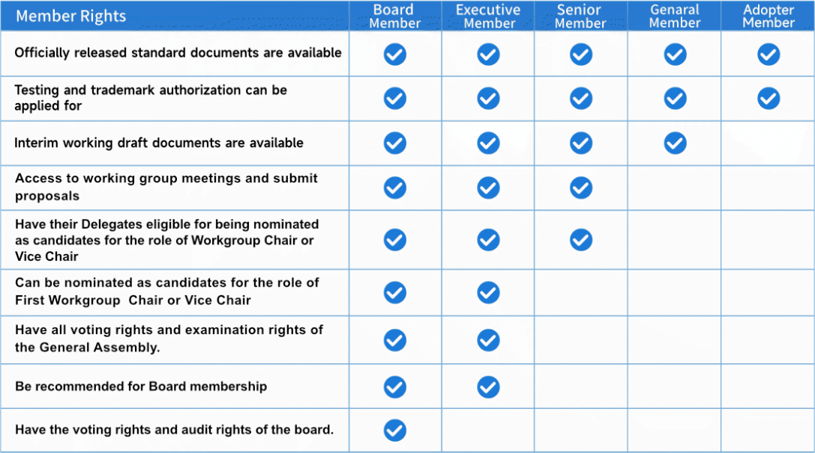

**Annex II: Membership fee standard (per year)**

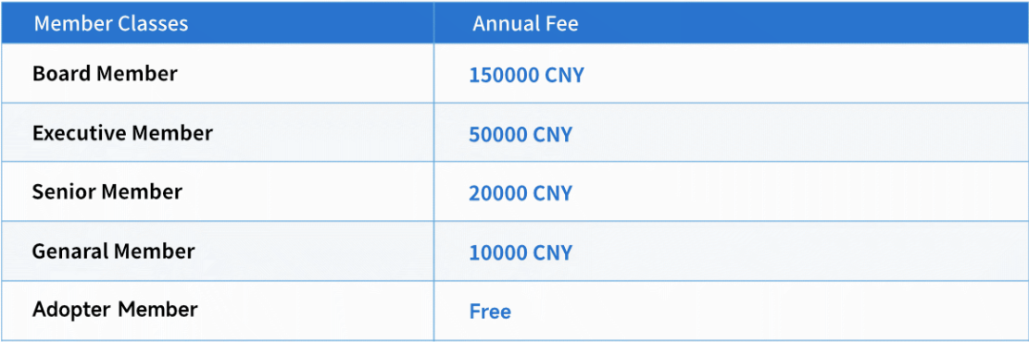

**Annex III: Association Bank Account**

I. Non-Hong Kong dollar Account

|  |  |  |
| --- | --- | --- |
| **Account Name:** | INTELLIGENT TERMINAL MICROELECTRONICS ASSOCIATION LIMITED | |
| **Account Number:** | 01286620088630 | FCY Savings Account(C) |
| **SWIFT Code:** | BKCHHKHHXXX | |
| **Bank Code:** | 012 | |
| **Bank Name:** | BANK OF CHINA (HONG KONG) LIMITED, HONG KONG | |
| **Bank Address:** | BANK OF CHINA TOWER, 1 GARDEN ROAD, CENTRAL, HONG KONG | |

II. Hong Kong dollar Account

|  |  |  |
| --- | --- | --- |
| **Account Name:** | INTELLIGENT TERMINAL MICROELECTRONICS ASSOCIATION LIMITED | |
| **Account Number:** | **01286620088627** | **HKD** |
| **SWIFT Code:** | BKCHHKHHXXX | |
| **Bank Code:** | 012 | |
| **Bank Name:** | BANK OF CHINA (HONG KONG) LIMITED, HONG KONG | |
| **Bank Address:** | BANK OF CHINA TOWER, 1 GARDEN ROAD, CENTRAL, HONG KONG | |